Click Here to Watch the Video Introduction

Fratres,

My name is Eitan Weinbaum (Sigma Chi, ‘19). I am a Communications Intern for SAM HQ.
We have been a Chapter specific social media content calendar to provide you to use. Think of this as a database of social media templates which you can personalize and share unique social media posts on a monthly basis. Each month has a plethora of options to choose from with your posts. Pick and choose for what fits your chapter's brand. We recommend aiming for around 4 a month to keep your feed constantly updated with innovative and engaging content.

Each post also includes a "copy" of what your post can look like. This includes a sample caption and graphic. Again, these templates are merely suggestions, so feel free to take those general ideas and spruce them up to cater to your chapter!

We're very excited to roll this content out to the chapters and are sure you will all get a lot of use out of it. If you have any questions, please contact our Director of Communications, Kelby Dolan at kelby@sam.org.

F&F,
Eitan Weinbaum

Academic:

Midterm Study Advice
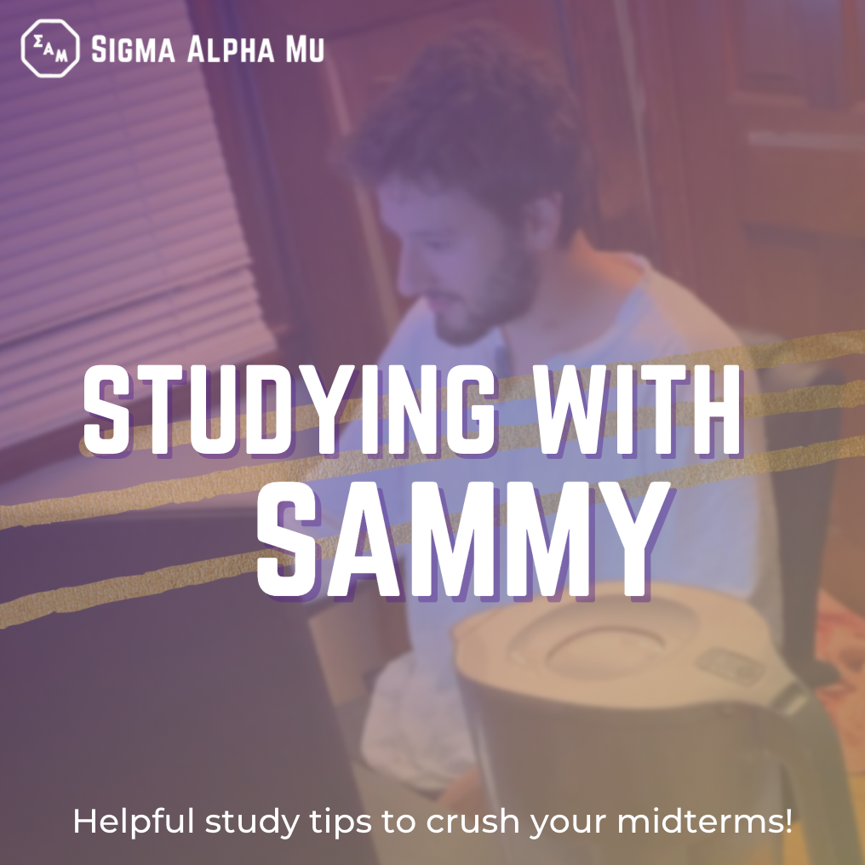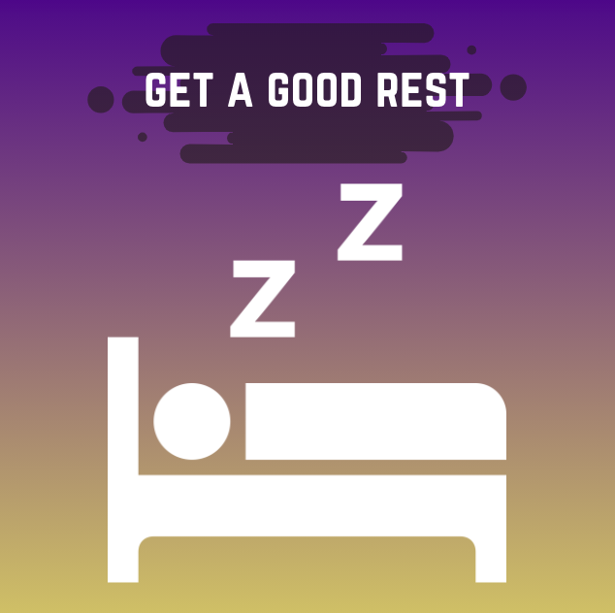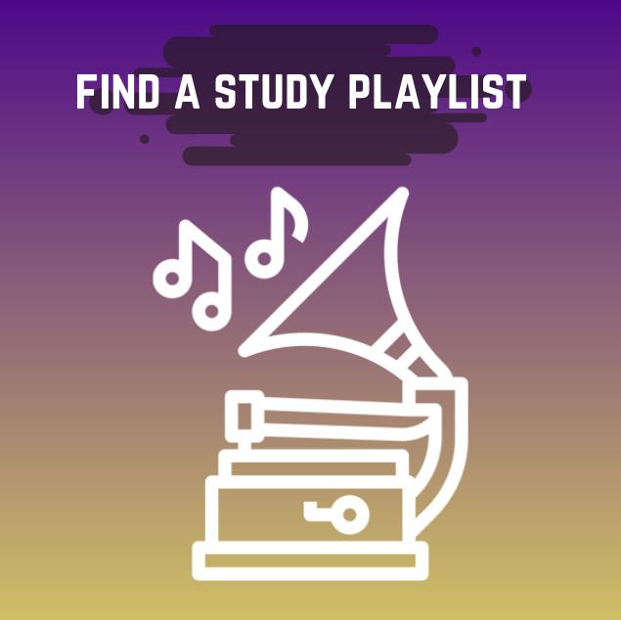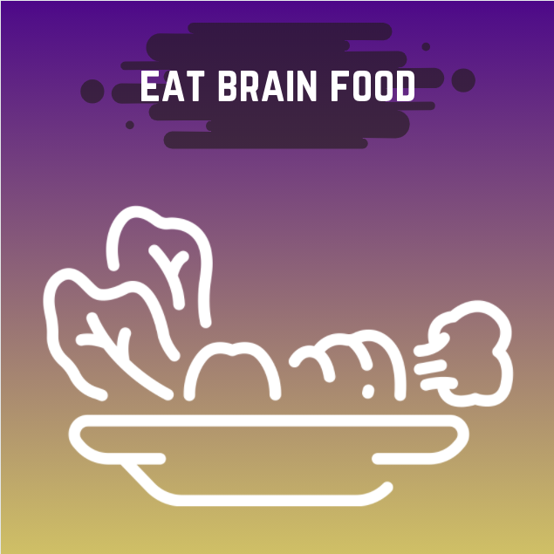
With midterm season here, use our 4 tips to help study best:
- Avoid outside distractions. Find a quiet environment to study. “Reserving a study room in the ESJ building helps me study best” says frater Matthew Winson (sample quote)
- Get a good night's sleep to help you retain more information. Take a 20 minute break after every one hour of studying.
- Stay focused by listening to your favorite Spotify or Apple Music playlist. Check out [playlist name].
- Eat brain food. For example, peppermint will help you focus during any activity requiring concentration.
For more on positive study habits, please visit [insert website here (UMD example: https://tutoring.umd.edu/studyskills.html] and good luck on those midterms.

Resources to Vote
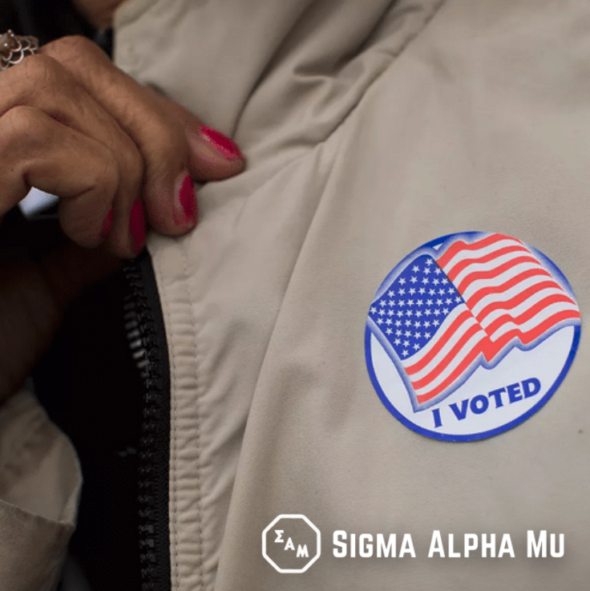
Where do you go to vote? What are your options? Go to (INSERT RESOURCE TO FIND LOCAL VOTING CENTERS).

With the national election on Tuesday, November 3, the Sammys at [insert university] would like to remind you to go out and vote. Voting gives you a voice in our democracy as we are called upon by our Fraternity’s creed. #Truemdh #yourvotecounts

Scholarships Post
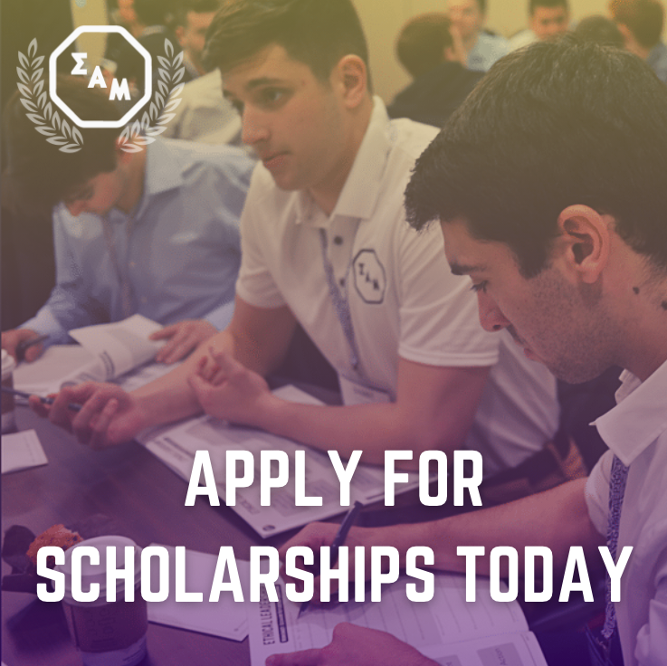
The Sigma Alpha Mu Foundation Scholarship Application has just been released! The Sigma Alpha Mu Foundation offers a wide range of scholarships for all fratres in undergrad or graduate programs and some for non-fratres as well. The applications are due February 7th, so get started on your application as soon as you can. For more information on the different scholarships and the application itself, please visit: http://sam-fdn.celect.org/home

Scholarship Reminder
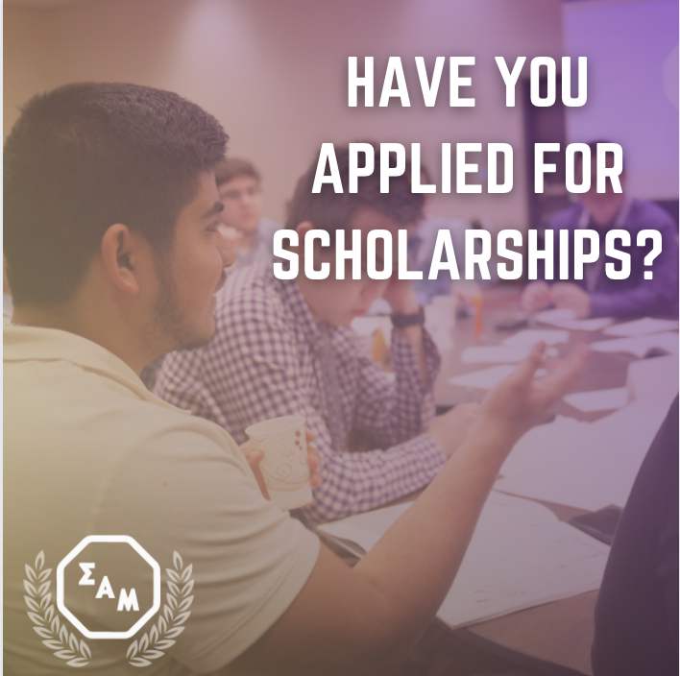
This is a reminder that the Sigma Alpha Mu Foundation Scholarship Application is due by February 7th! The Sigma Alpha Mu Foundation offers a wide range of scholarships for all fratres in undergrad or graduate programs and some for non-fratres as well. There is still time to fill out the application, so get started today. For more information on the different scholarships and the application itself, please visit: http://sam-fdn.celect.org/home

Finals Study Advice
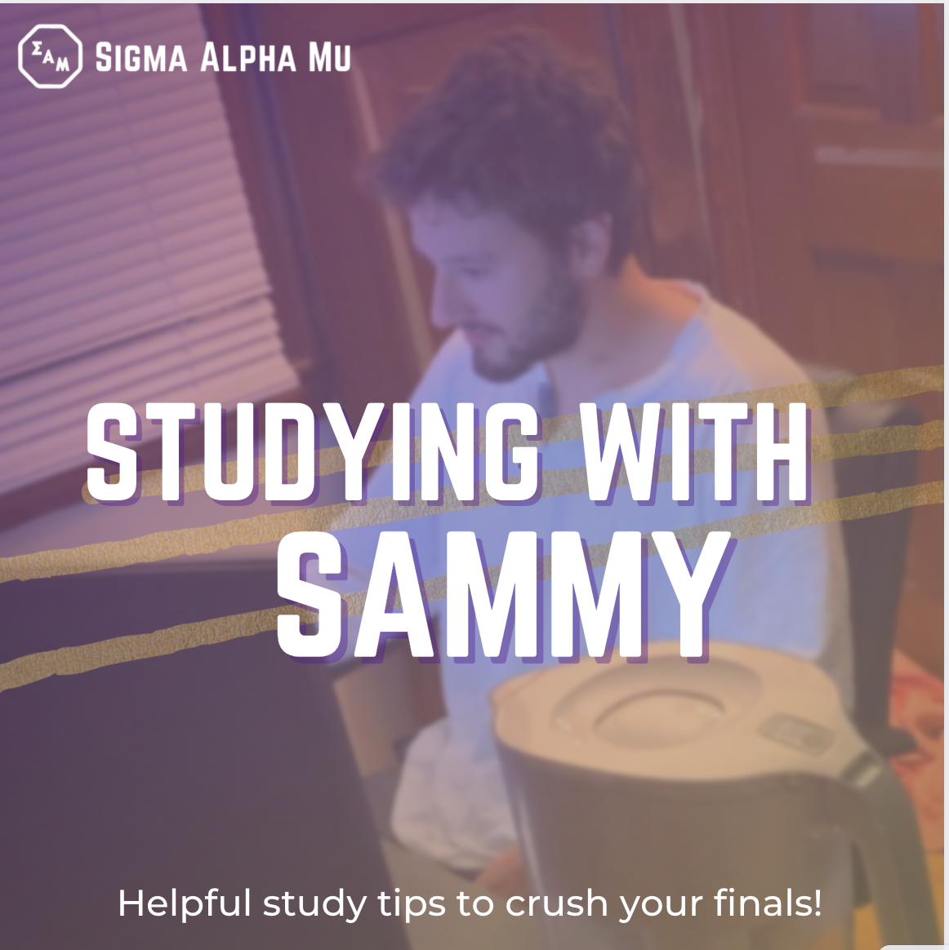

With finals season approaching, here our some of our fratres’ best study tips to succeed on their finals:
- Create a study schedule giving time for each class and study breaks
- Get a good night to retain information from studying
- Eat brain food. Nuts and eggs contain nutrients that support brain and memory development.
We would like to wish everyone good luck on their finals and cannot wait to see everyone back on campus after winter break!

Study Abroad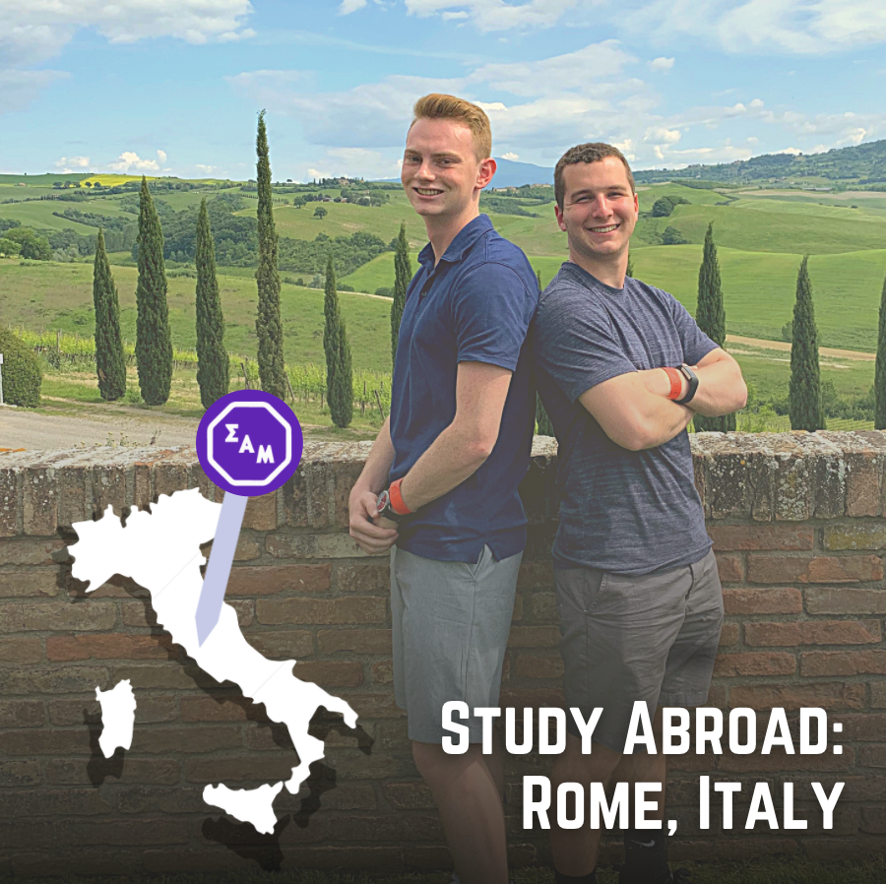
While the majority of our fratres have been enjoying their semester in College Park (change cities depending on school), Fra Evan Devore and fra Matt Kalin studied abroad in Roma, Italy. Evan shared, “The city of Rome is beautiful. I met people I will never forget. While I miss hanging out with my brothers every week, I know I proudly represented our organization from across the Atlantic.” Evan and Matt will rejoin us in College Park (change cities depending on school) next semester. To learn more about Maryland’s study abroad program feel free to message Evan at [insert Insta handle] or Matt at [insert Insta handle] to hear about their experiences, Also, please visit Maryland’s study abroad program’s office at: https://globalmaryland.umd.edu/offices/education-abroad

Chapter Specific:

Chapter or Alumnus Sammy History (Homecoming - Reunion - HYH Achievements)
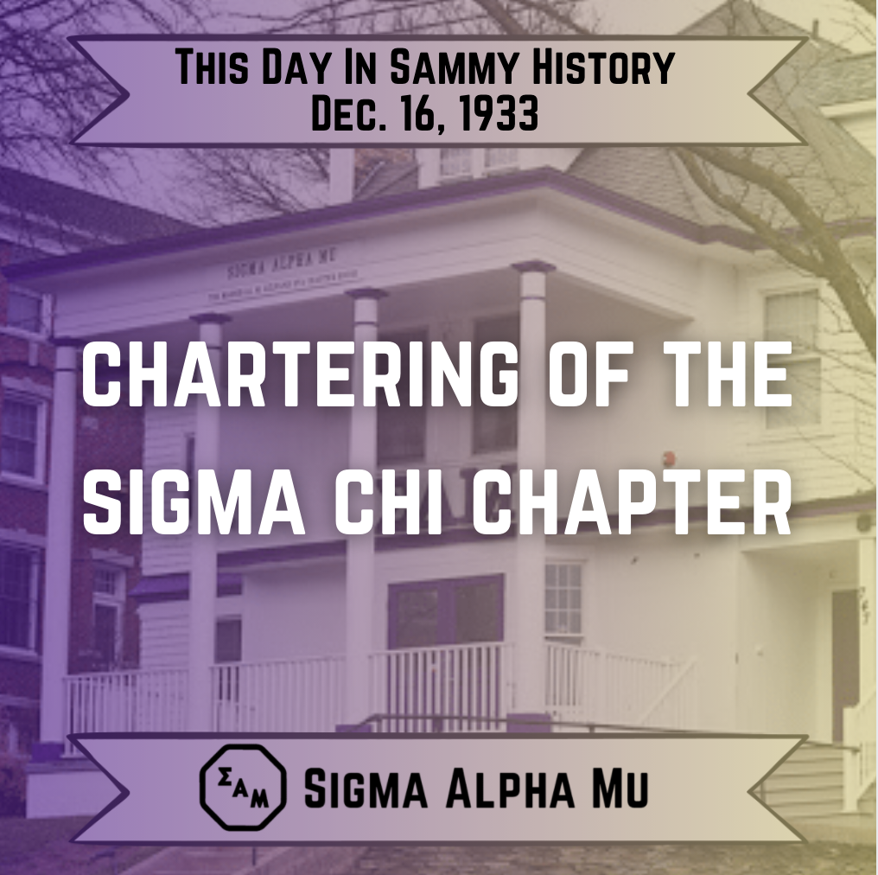
On this day in Sammy history (using an example of December 16th), our Sigma Alpha Mu--Sigma Chi chapter at the University of Maryland chartered. After 87 years, our chapter initiated 1,300+ brothers that embody our fraternity’s core values. We appreciate all of the alumni and all those who dedicated themselves to helping our chapter. We look forward to the next 87 years of our beloved fraternity. #Truemdh

Advisor/Volunteer/Professor of the Month
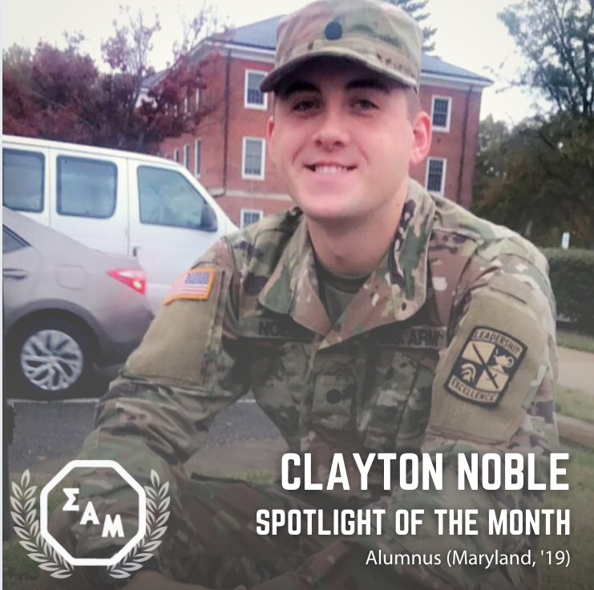
Shoutout to Sammy alumnus, Clayton Noble (Maryland, ‘18), who serves as a member of the United States Army Reserves. Clayton, a founding father of our chapter, served as our chapter’s first prior in (insert year). Fra Noble shared, “ (Sample Quote) I am proud of the legacy I left at our chapter and I am looking forward to where the current brothers take us” As an alumnus, we appreciate the volunteer commitment he continues to inculcate within our active members Nominate an alumnus, advisor, volunteer, or professor to be our Sammy community member of the month at the link below: [insert Google form nomination link]

Thank you to previous council
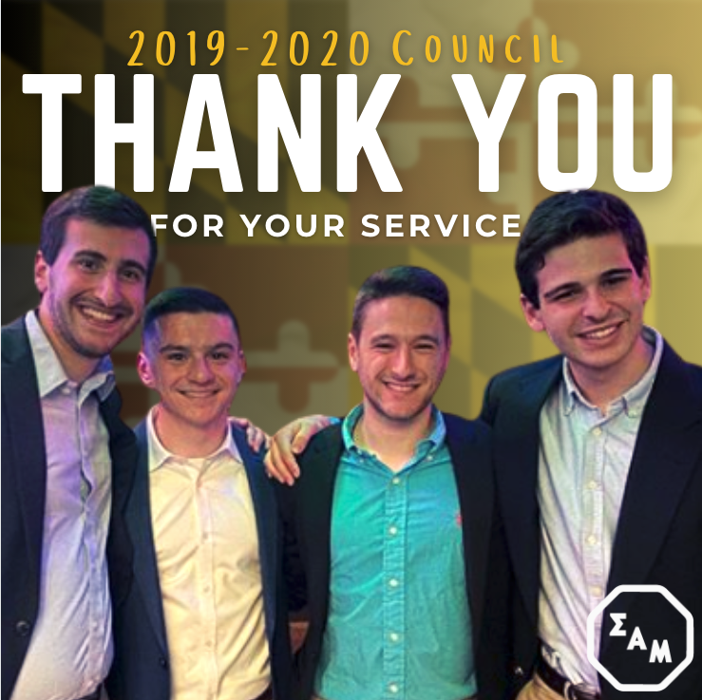
We would like to thank our council (Insert names: Adam Rosenbaum, Mat Steininger, Scott Bayer, and Joshua Averbach) for all they accomplished for our chapter. Highlights include winning the President’s Cup, the award for most outstanding chapter at our university, and progressing our chapter to Founder’s Level. They left a legacy for our chapter that our new council (Matthew Winson, Eitan Weinbaum, Joshua Mendelson, Ethan Jaffee) will emulate.

Chair of the Semester
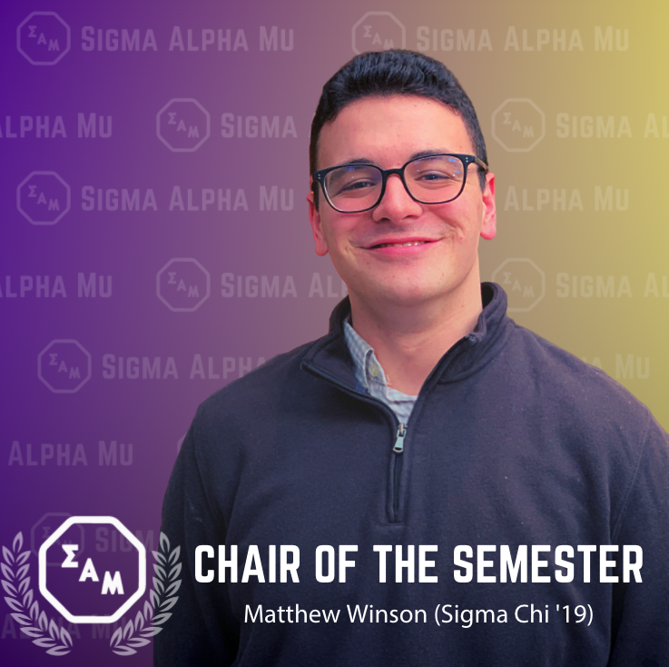
We would like to congratulate frater Matthew Winson for winning the chair of the semester award. Matthew, a sophomore government and politics major, served as parent-alumni chair for the past 2 semesters where he developed multiple editions of our chapter’s newsletter and successfully adapted alumni events to an online setting. If you are an alumnus or parent who is not currently receiving our newsletter, go to samumd.org to sign up.

Welcome Back to School
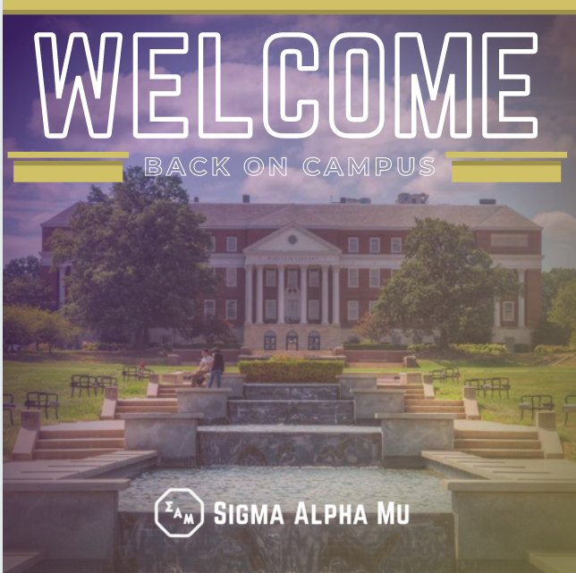
After a long break, we welcome everyone back to campus! Whether we are recruiting our newest class of brothers, supporting the Judy Fund, or pushing each other in our academic endeavors, Sammy will conquer this semester! Take a look at our chapter’s goals for the upcoming semester, check out our website [WEBSITE LINK: www.samumd.org].

Graduation
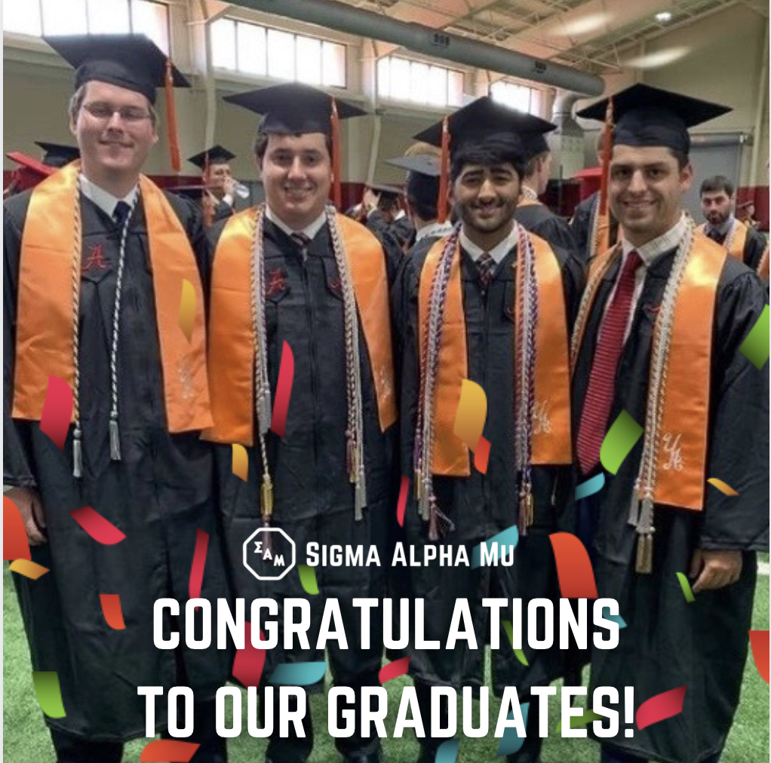

We would like to congratulate all of our fratres (list them or use the photos as a group picture of them) who are graduating at the end of the semester! Both fratres graduating were founding members after our rechartering and have seen all of the growth of the chapter ever since. Graduating fratre Harry Huntley said, “I am so proud to see our chapter initiate over 40 fantastic men into the brotherhood during my time in the chapter”. We wish the best of luck to all graduates in their future endeavors and look forward to finding the next group of potential fratres in a couple months. To learn more about our chapter, our values, and our brothers, check out our Instagram page @sam_umd or our website: samumd.org

Summer with Sammy
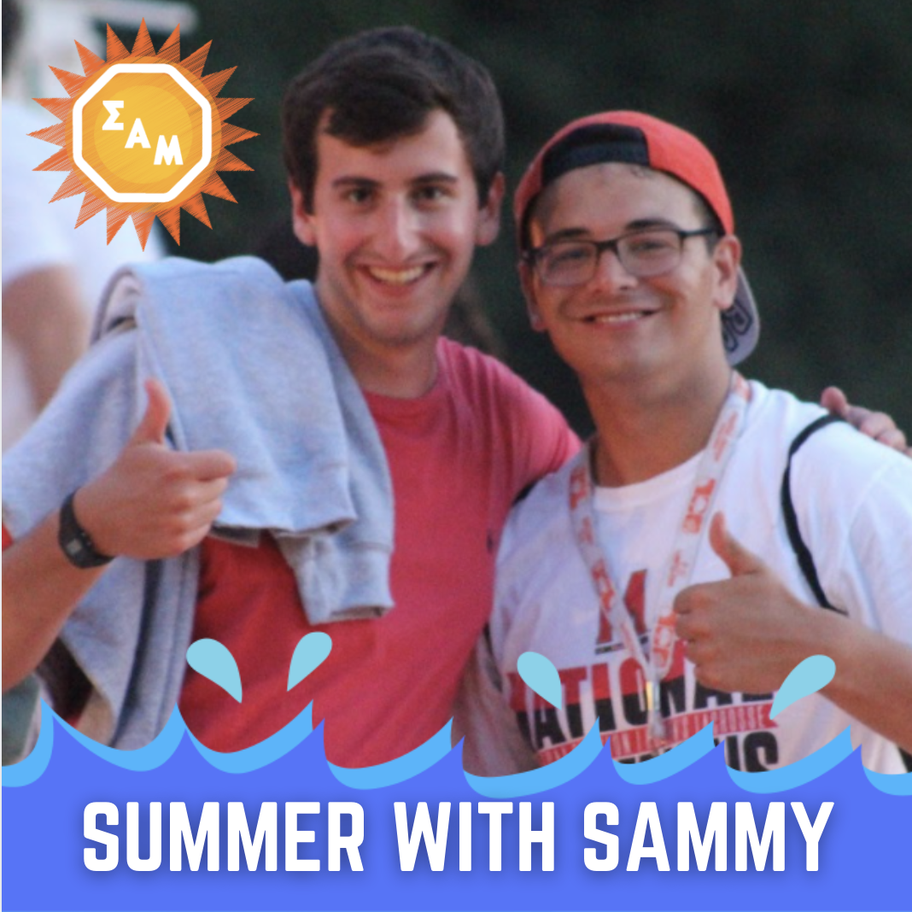
We hope everyone has been enjoying their summer break so far. Here is how some of our brothers have been active in their communities. Fra Matthew Winson (Fall ‘19), and Fra Mat Steininger (Spring ‘19) worked at a sleepaway camp, Capital Camps. as counselors for kids aged 8-10 giving them a summer full of experiences. Have you been to a summer camp before?

Winter Break Update:
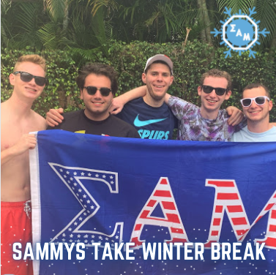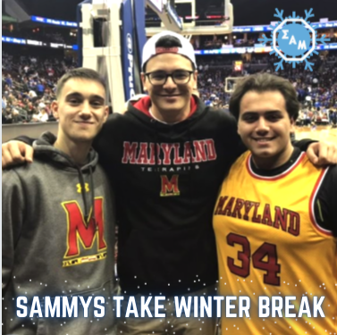
While away from campus this winter break, fratres Matthew Winson, John-Michael Aldorasi, and Zach Solon met up with each other in Newark, New Jersey to watch the Maryland men’s basketball team play at Seton Hall. Fratres Evan Devore, Zach Solon, Josh Fein, Eitan Weinbaum, and Matt Kalin building bonds at the beach in Fort Lauderdale, Florida. Tag any fratres you have seen this winter break and let us know where!

Composites:
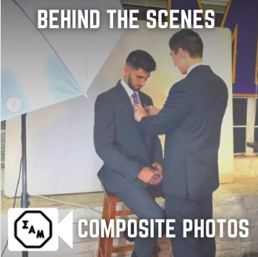
Here are some behind-the-scenes photos from our fratres getting their composite photos taken. Every year our chapter and chapters around the country make composites, which are large, framed, collections of photos of every member currently active in the chapter for that year. Composites are a way for everyone to see and remember the fratres of the past that helped build our chapter to what it has become and a way for the current fratres to leave a lasting legacy for the future. It is also great practice for getting professional headshots. Come see our past composites at our chapter house at [insert house address]

Founder’s Day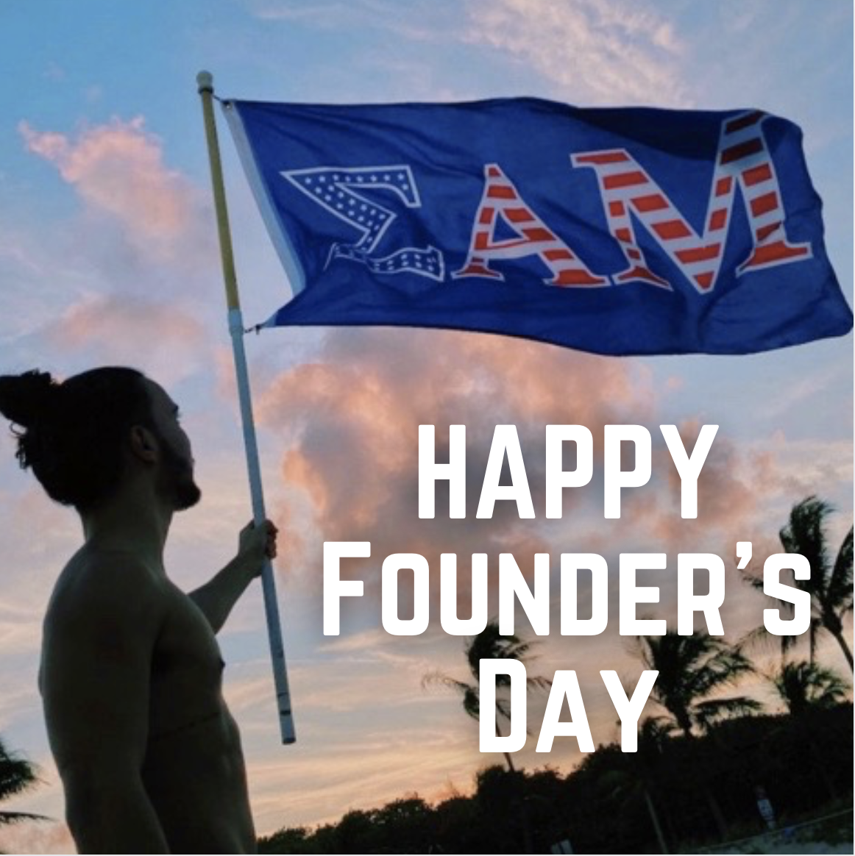
On November 26th, 1909, eight brave, young men founded our great brotherhood. Today we are thankful for everything that our fellow and past fratres have given us to help make our chapter successful and grow as men. We look upon our letters with pride and joy remembering everything our brotherhood has given to us. We hope our organization has helped all of our members grow to become proud fratres representing true mahood, democracy, and humanity. Tag your mentors and friends you are thankful for and helped you grow into the person you are today. #Founder’sDay #F&F #TrueMDH

Chapter Event:

National Drug and Alcohol Facts Week
With this week being National Drug and Alcohol Facts Week, every weekday we are giving out some helpful information to make sure you are aware of the effects of addictive drug and alcohol use on the body. Today we are looking at the risks of vaping and e-cigarettes, which contain the addictive substance nicotine. According to the CDC, using nicotine in adolescence can harm the parts of the brain that control attention, learning, mood, and impulse control. To learn more about National Drug and Alcohol Facts Week please visit: https://teens.drugabuse.gov/

Recruitment
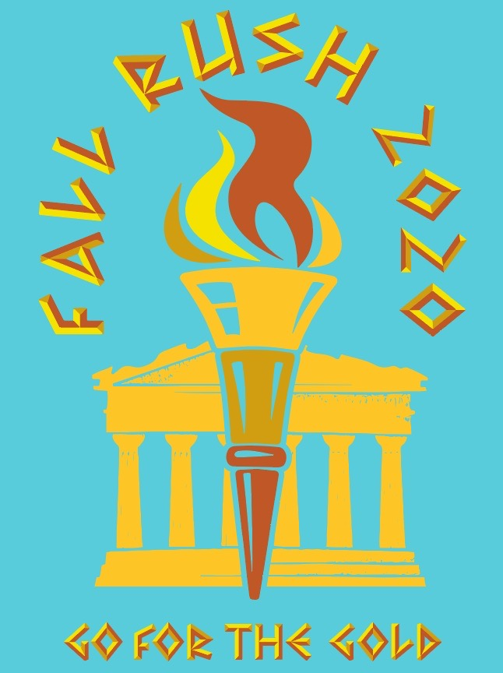
With the official recruitment period approaching, we look forward to finding our next group of fratres. We hope to find potential new members that truly represent true manhood, democracy, and humanity as well as the 8 pillars of the Octagon. To learn more about our chapter, watch our recruitment video above, visit our Instagram page @sam_umd, or our website samumd.org. Also feel free to contact our rush chairs, Ryan Petersen (insta handle or Facebook name) and Dylan Josephson ((insta handle or Facebook name) if you have any questions.

WHY SAMMY:

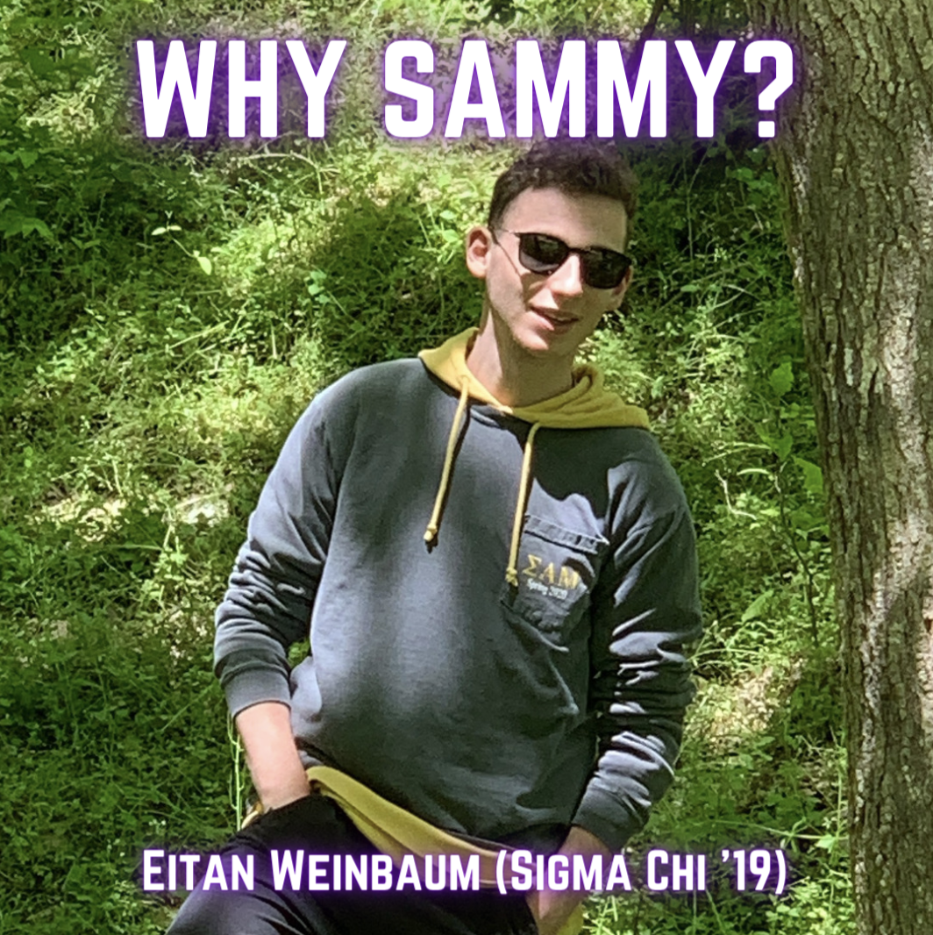
During this rush season, we asked our fratres why they decided to join our brotherhood. Fra Eitan Weinbaum said “I joined Sammy because the second I came to my first event I could tell that all the brothers cared about getting to know me on a personal level. I just got that feeling these were my people, and it was only the second week of school”. To hear more about Eitan’s reasons for joining the Sammy brotherhood and the feelings of our other fratres, come meet us at our next rush event [insert next event info or direct to rush card] or contact our rush chair [insert rush chair and insta handle].

Alumni Event Sample
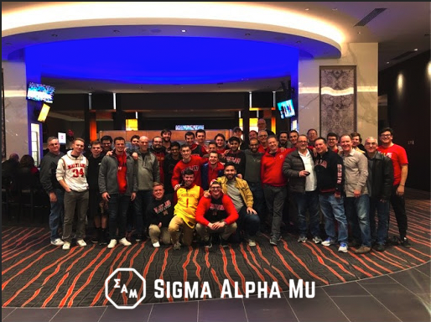
This past Saturday, a group of alumni from our chapter met many of our current fratres in the lobby of The Hotel. It was a great time being able to share stories with the alumni about chapter life over the past 35 years. Fra Steven Phillips shared, “it was amazing to hear the stories of our alumni when they lived in 2 Fraternity Row all those years ago.” To hear about when our next alumni event will be, please follow our chapter on Instagram and Facebook [insert the account info here].

Day of Giving
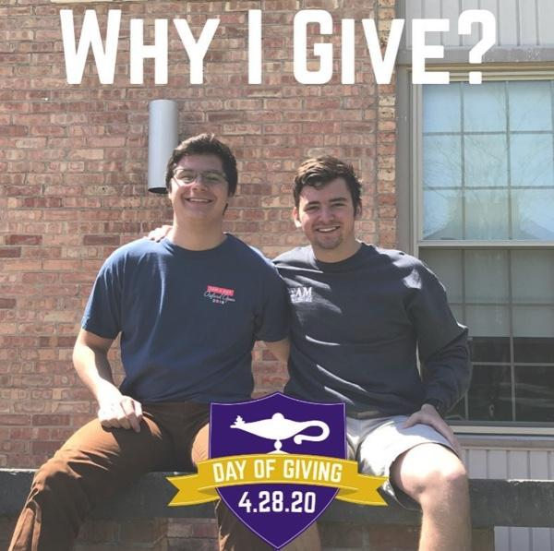
The Sigma Alpha Mu Foundation and its Day of Giving provide scholarships for college students, funding for education spaces in ΣAM chapter houses and grants for educational programs that promote leadership. Day of Giving social media ambassador Brian Velasquez shared,“I was a recipient of the Jerry Miller Scholarship for the 2018-2019 academic year through the ΣAM Foundation. Jerry was not only an advisor, but also a mentor and a friend.” To learn more about the Sigma Alpha Mu Foundation or to give donations on April 28th, 2020 during the #SAMDayofGiving check out https://samdayofgiving.org/ to give someone an opportunity just like Brian’s.

Philanthropy Event Sample
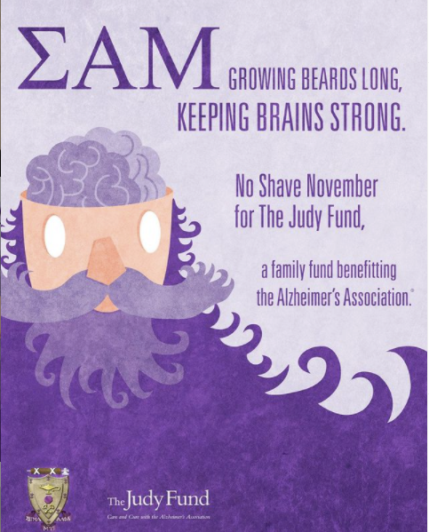
Every November, our fratres participate in the No Shave November fundraiser where many fratres do not shave for the month in support of raising money for the Judy Fund. The Judy Fund takes donations and puts it towards Alzheimer’s research. As humanity is one of our fraternity’s core values, it is our duty as people to help raise funds to save the lives of others suffering from this horrible disease. Over the next month, we will be posting pictures of our fratres and their growing beards. You can vote for who is growing the best beard by donating to the Judy Fund at http://act.alz.org/site/TR?fr_id=14244&pg=personal&px=18785871 which is also in our bio. Please donate to save lives!!!

Community Service Event Sample
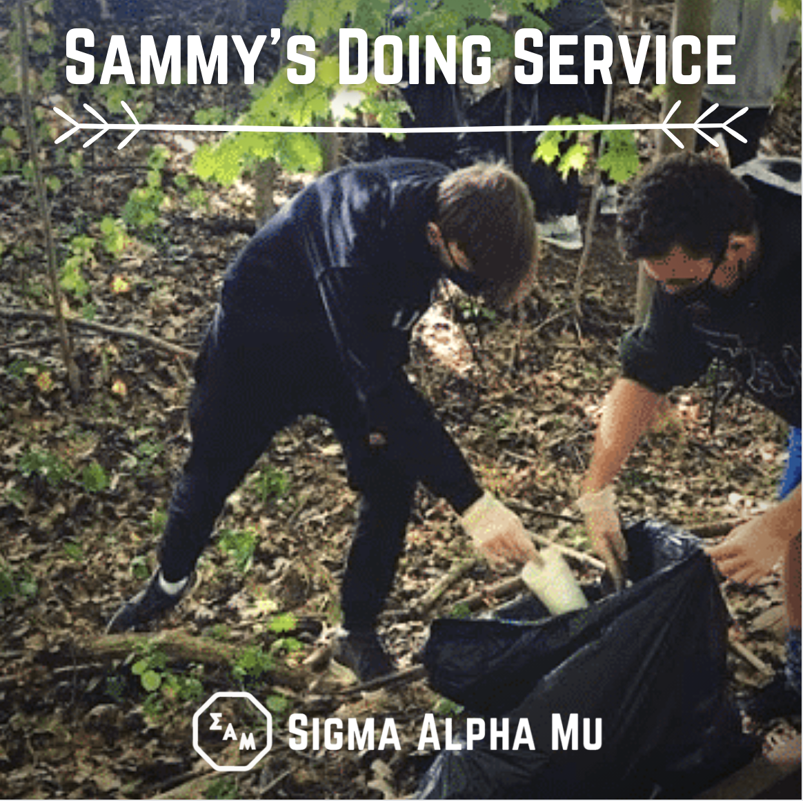
Last weekend our fratres went out to Mass Central Rail Trail to help pick and properly discard trash littered around the area. One of our core values as a chapter is humanity, and one way we can help sustain a world for all of humanity is to clean up our environment. Text your friends to go out to local parks to pick up trash and help keep our world safe and clean. #truemdh

Holiday:

MLK Day
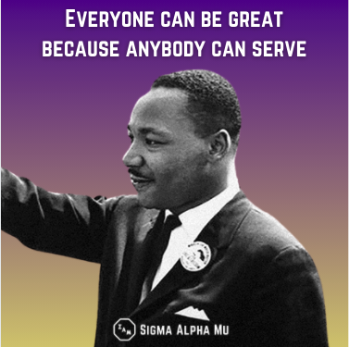
Every third Monday of January, we honor the life and legacy of Dr. Martin Luther King Jr. Dr. King’s actions embody the highest precepts of true manhood, democracy, and humanity. Our chapter spends MLK Day as a day of service for our local community. To learn more about MLK, get involved in our MLK Day of Service, visit: https://www.nationalservice.gov/serve-your-community/mlk-day-service

Happy Holidays
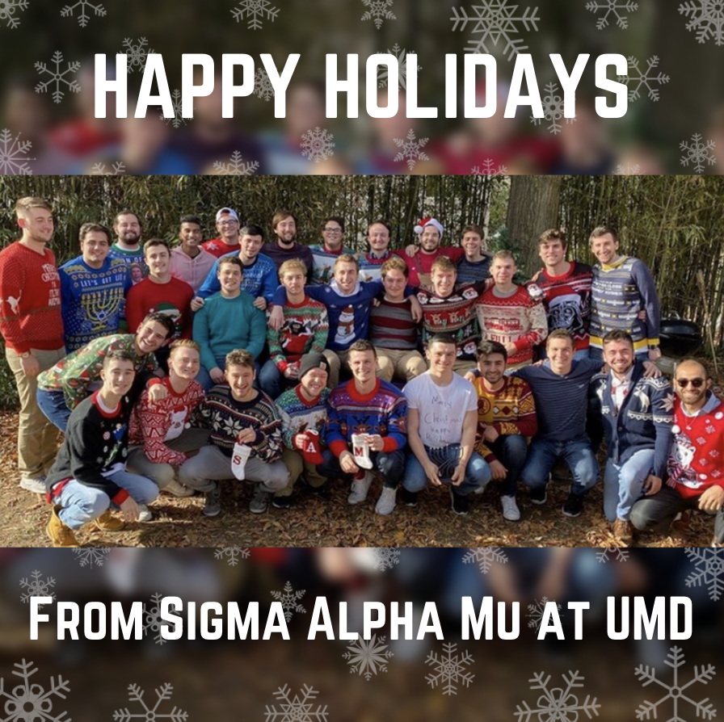
The Sigma Chi (use your chapter name) chapter of Sigma Alpha Mu would like to wish everyone, their friends, and their families a Happy Holidays. Take this time over the holiday season to think about what you are most grateful for in your life and how you can make the most of the relationships in your life. Tell us what you are most grateful for this holiday season in the comments!!!

Happy New Year
The brothers of the Sigma Chi chapter of Sigma Alpha Mu want to wish everyone a Happy New Year! The beginning of a new year is a time for all of us to think about resolutions and goals to achieve for the upcoming year. Some of our chapter’s New Year’s resolutions include: recruiting a large number of new fratres and raising over $1000 for the Judy Fund. What are some of your New Year’s resolutions? Tell us in the comments

Holocaust Remembrance Day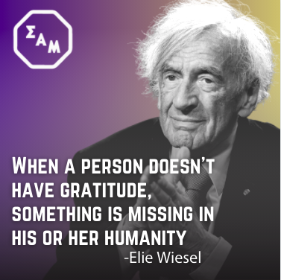
Today, we remember the lives of all those lost during the Holocaust over 75 years ago. Holocaust survivor Elie Wiesel says “When a person doesn’t have gratitude, something is missing in his or her humanity. A person can almost be defined by his or her attitude toward gratitude.” The fratres of Sigma Alpha Mu try to live up to Wiesel’s quote through our fraternity’s core values of #truemdh by showing gratitude towards the people in our lives. To learn more about the Holocaust, we highly recommend visiting the US Holocaust Memorial Musem in Washington, DC or check out their website: https://www.ushmm.org/

Valentine’s Day
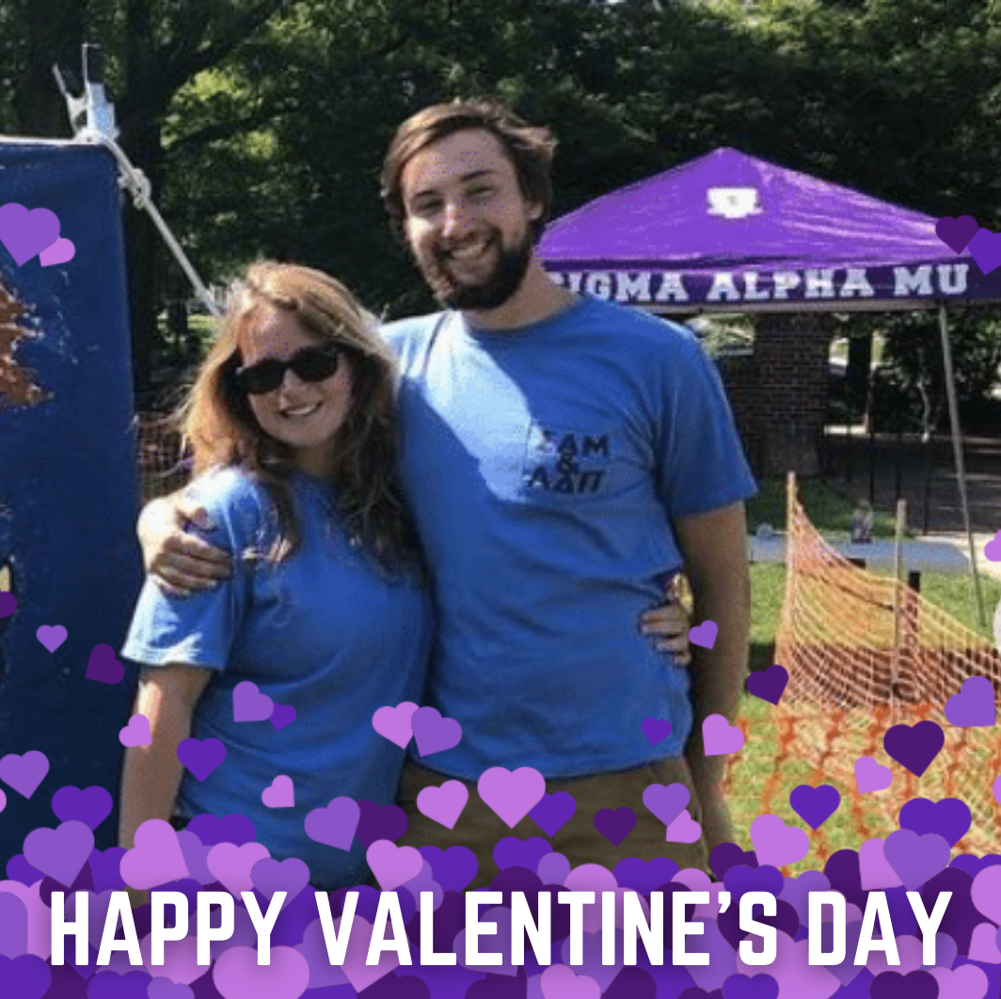
Happy Valentine’s Day to our chapter’s sweetheart Sarah __! Sarah graduated from the University of Maryland and is currently living in Annapolis, Maryland. This Valentine’s Day, our chapter is giving out candy grams for anyone on or off-campus who would one or would like one to be sent to a friend. The candy grams cost $5 and all proceeds go to the Judy Fund for Alzheimer’s Research. For more information on the candy grams check out the link in our bio.

President’s Day
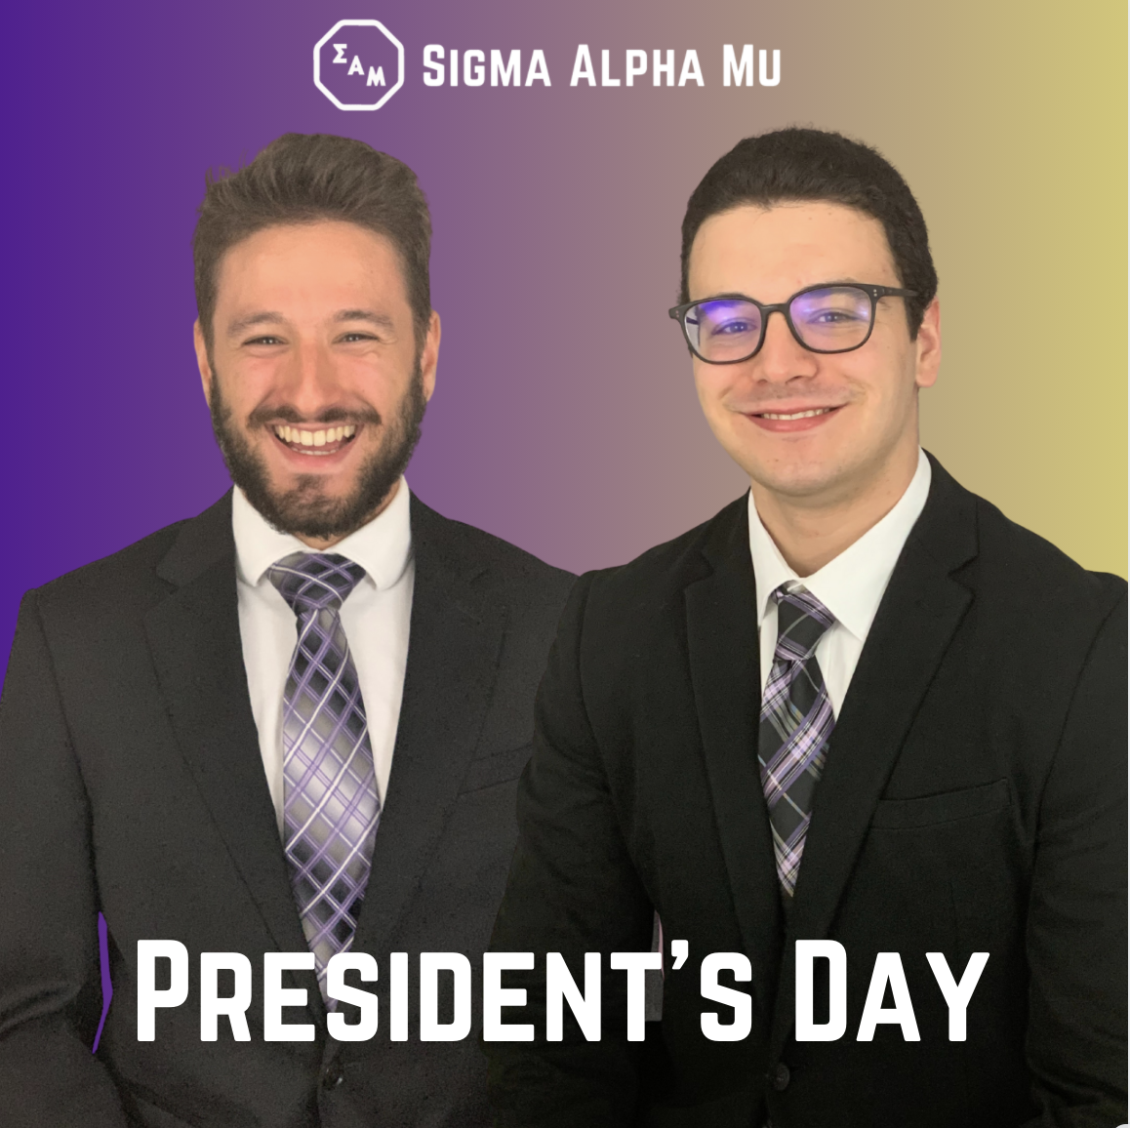
This President’s Day we would like to thank all of our past priors and our current prior, Matthew Winson, for all the work they have done for our brotherhood. Fra Winson shared “Our past priors worked tirelessly to lead our fratres to where we are today. I hope to follow in their footsteps and leave a lasting legacy to help our brotherhood grow.” To learn more about our current prior Matthew Winson, check out his vision for our chapter on our website: www.samumd.org

Black History Month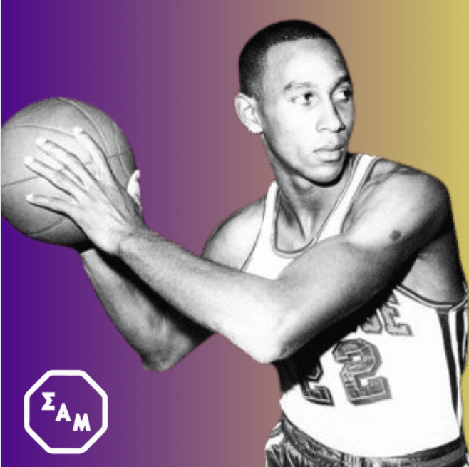
During Black History Month this year, we want to spotlight Fra Dave Bing (Syracuse, ‘66). Fra Bing was a 7-time All-star and was inducted into the Basketball Hall of Fame in 1990. Fra Bing was also awarded the National Civil Rights Museum Sports Legacy Award in 2009 and served as the mayor of Detroit from 2009 to 2013. To learn more about the National Civil Rights Museum and the Sports Legacy Award check out: https://www.civilrightsmuseum.org/

Just for Fun:

Black Friday Haul - Sammy Swag Store - Set up your Gift List:

Buy local-support small business on Black Friday from Alumni

During black friday, here’s what our fratres were able to score. [INSERT INTERESTING THINGS BROTHERS BOUGHT]. If you are looking for cool merch or a stellar gift, check out the Sammy Swag Store for some exclusive Sammy gear! #SammySwag #DontSleep #popupshop

Graphic: Collage of pics of brothers showing off some cool clothes they got from Black Friday shopping

National Trivia Day:
Today is National Trivia day! Our chapter is holding a special trivia contest on our Instagram Story TODAY ONLY where a group of winners will receive a special prize from our brothers. Check our instagram stories for some fun Sammy trivia questions!
- Post some fun facts about your chapter in quiz form such as…
  - Where was Sigma Alpha Mu founded
  - What’s our philanthropy
  - What year was our chapter founded
  - What’s our president’s name

Graphic: No main post for the page, rather quizzes on Instagram stories. This is done via the Instagram app.

National Puppy Day
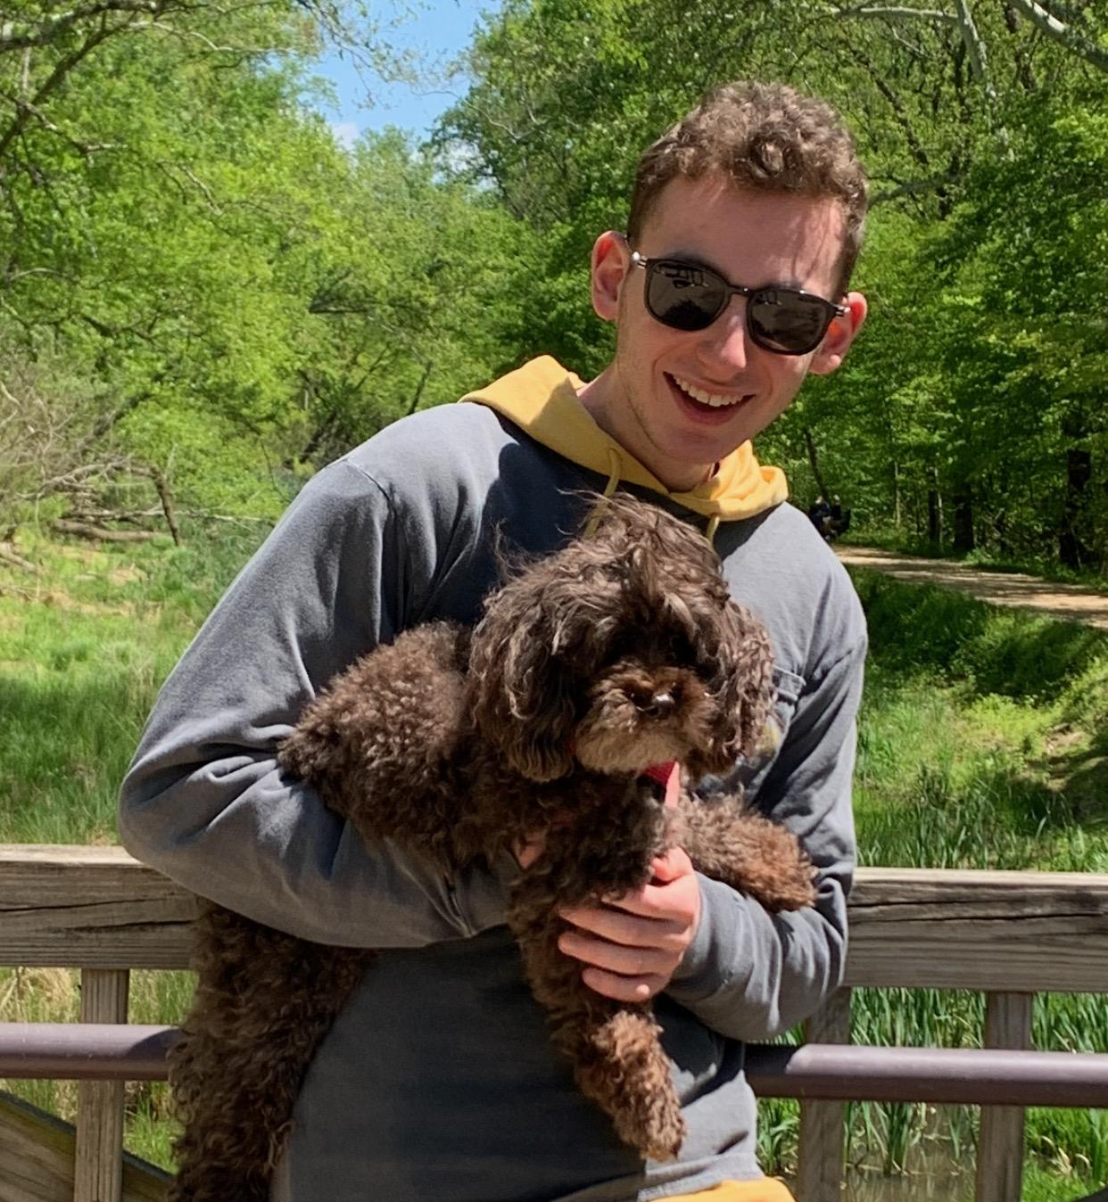
Today is National Puppy Day, so we wanted to shout out the best friends of some of our fratres and their families. From the first picture to the last one we have Fra Matthew Winson with his dog Joy, Fra Eitan Weinbaum with his dog Tedi, and Fra Adam Rosenbaum with his dog Prince. Dogs act as our brothers at home as people who we can find comfort in and know we can always have a fun time with them. Tell us whose “man’s best friend” is the cutest.

Superbowl Sunday
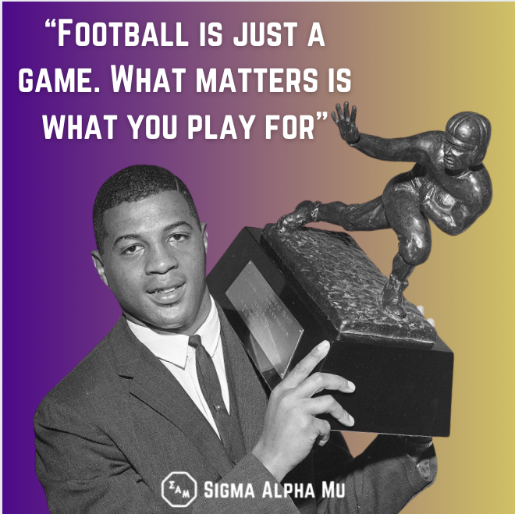
We hope everyone is excited to watch the Super Bowl tonight. Sigma Alpha Mu frater Ernie Davis (Syracus ‘60) was the first African American Heisman trophy winner famously saying “Football is just a game. What matters is what you play for.” Tell us who you think is going to win the Super Bowl and what the final score will be in the comments below.

TO DO:

CLD:
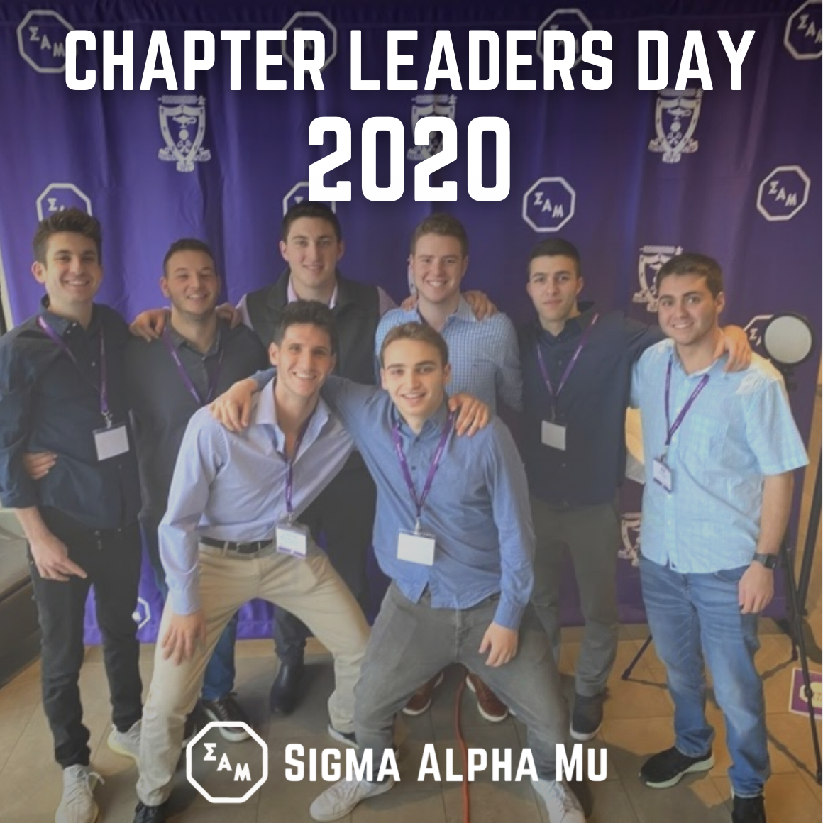
This past February, our council and emerging leaders in our brotherhood attended Chapter Leader’s Day in Indianapolis along with other chapters in the region. There, they worked through challenges focusing on values like leadership, fraternity, and humanity. Our fratres learned many useful skills to help lead our chapter new heights. [Anecdote from someone who attended CLD talking about something they learned] Thank you to @sigmaalphamu for putting on a wonderful workshop and it was a pleasure to meet the leaders from other chapters in the region.

SDT:

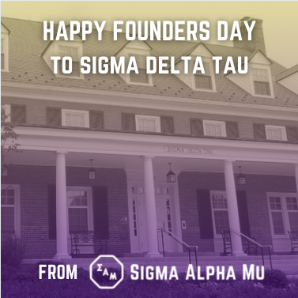
We would like to wish a happy Founders Day to the women of our sister chapter Sigma Delta Tau who are committed to empowering women through scholarship, service, sisterhood and leadership. We always enjoy growing as a community together planning community service and social events together. The women of SDT are truly worthy of the highest precepts of true womanhood, democracy, and humanity. #TrueWMDH

COLLEGE DECISION DAY:
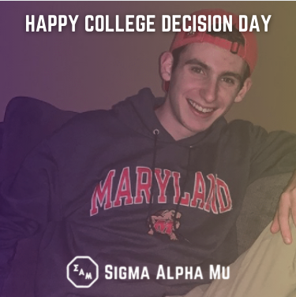
As today is college decision day, we would like to congratulate high school seniors on making the amazing choices of where to spend the next few years growing their education. You have all worked very hard to get to this point in your lives and you should be proud of our accomplishments to get you to this day. We also would like to welcome all students who have decided to join us in the fall at our beloved university. We look forward to meeting you all very soon and hopefully see many of you join our brotherhood in the near future. Tag some students that will be joining our beloved university this fall in the comments.

